Data Dictionary (for Process)

**Process name:**

**Process Description:**

**Inward flow(s):** it includes names of input data flows

**Outward flow(s):** it includes names of output data flows

**Process specification:** it includes details of code/ function written in Structured English

Data Dictionary (for Data flow)

**Data flow name:**

**Data flow Description:**

**Input Source:** it includes input process/source name

**Output Source:** it includes output process/source name

Data Dictionary (for Data Store)

**Data store name:**

**Data store Description:** it includes field name, data type, data format

**Input flows:** it includes names of input data flows

**Output flows:** it includes names of output data flows

**Process description:**

Structured English/ decision tree / decision table

Example:

Customer Authentication in the online shopping environment

This procedure to authenticate customer can be written in Structured English as:

Enter Customer_Name

SEEK Customer_Name in Customer_Name_DB file

IF Customer_Name found THEN

Call procedure USER_PASSWORD_AUTHENTICATE()

ELSE

PRINT error message

Call procedure NEW_CUSTOMER_REQUEST()

ENDIF

Draw Decision table, decision tree

**Data store:**

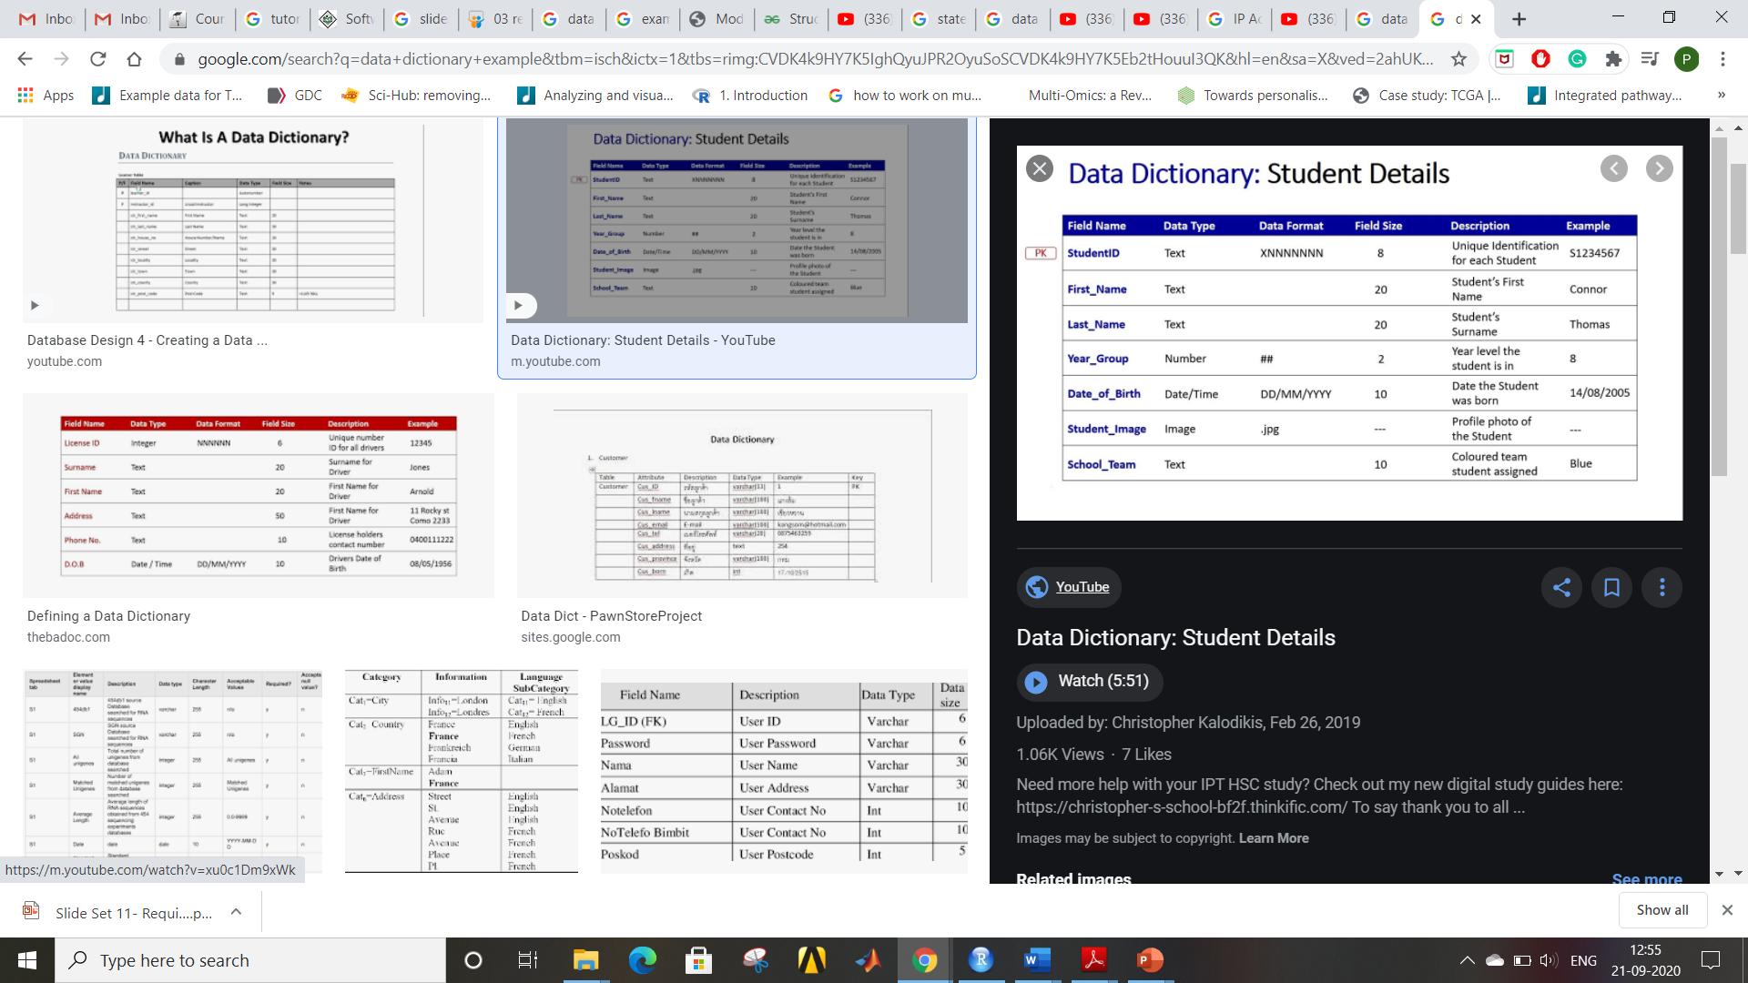

**Data Flow:**

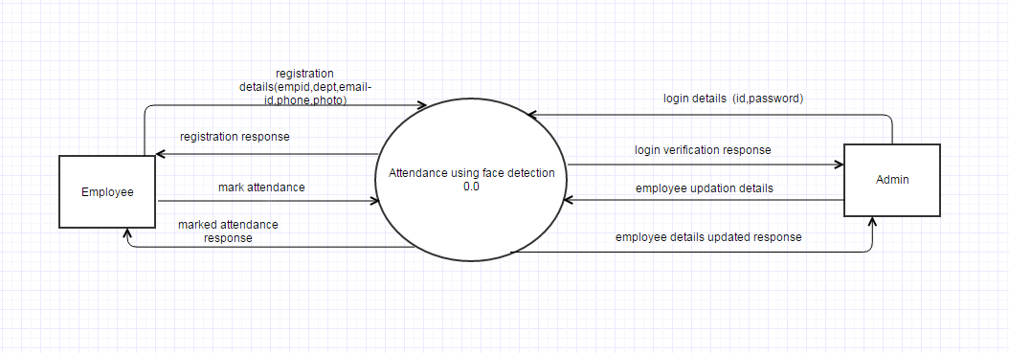

|  |  |  |
| --- | --- | --- |
|  | **DATA** | **DESCRIPTION** |
| 1 | Login details | Login details of the admin. It is required for successful login. Login details include id and password. |
| 2 | Login Verification response | Verification response message displays whether the id and password is correct or not. |
| 3 | Employee details | Employee details include employee id ,department, email-id, phone number, photo. |
| 4 | Employee added response | If employee details are added successfully in employee table then employee added successfully message will be displayed. |